To make the Google Play services APIs available to the app:
- Copy the library project at <android-sdk>/extras/google/google_play_services/libproject/google-play-services_lib/ to the location where you maintain your Android app projects.
- Import the library project into your Eclipse workspace. Click File > Import, select Android > Existing Android Code into Workspace, and browse to the copy of the library project to import it.
- In your app project, reference Google Play services library project. See Referencing a Library Project for Eclipse for more information on how to do this.
Note: You should be referencing a copy of the library that you copied to your development workspace—you should not reference the library directly from the Android SDK directory.
- After you've added the Google Play services library as a dependency for your app project, open your app's manifest file and add the following tag as a child of the <application> element:
<meta-data android:name="com.google.android.gms.version"
android:value="@integer/google_play_services_version" />
Once you've set up your project to reference the library project, you can begin developing features with the Google Play services APIs.

Referencing a library project

If you are developing an application and want to include the shared code or resources from a library project, you can do so easily by adding a reference to the library project in the application project's Properties.
To add a reference to a library project, follow these steps:
- Make sure that both the project library and the application project that depends on it are in your workspace. If one of the projects is missing, import it into your workspace.
- In the Package Explorer, right-click the dependent project and select Properties.
- In the Properties window, select the "Android" properties group at left and locate the Library properties at right.
- Click Add to open the Project Selection dialog.
- From the list of available library projects, select a project and click OK.
- When the dialog closes, click Apply in the Properties window.
- Click OK to close the Properties window.
As soon as the Properties dialog closes, Eclipse rebuilds the project, including the contents of the library project.
Figure 2 shows the Properties dialog that lets you add library references and move them up and down in priority.
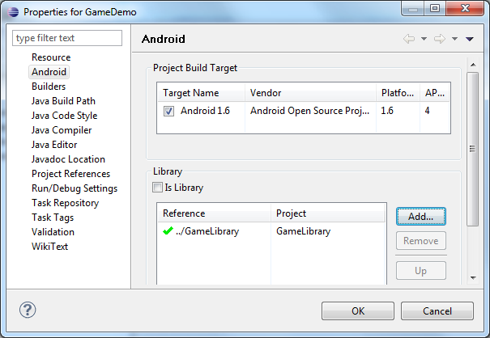
Figure 2. Adding a reference to a library project in the properties of an application project.
If you are adding references to multiple libraries, note that you can set their relative priority (and merge order) by selecting a library and using the Up and Down controls. The tools merge the referenced libraries with your application starting from lowest priority (bottom of the list) to highest (top of the list). If more than one library defines the same resource ID, the tools select the resource from the library with higher priority. The application itself has highest priority and its resources are always used in preference to identical resource IDs defined in libraries.

